Introduction

The purpose of this document is to help the user know how the system will be designed starting with classes then the interaction between classes, it’ll also help the user know how the database is designed, the document also contains table of definitions for every abbreviation used in the document.

ER Diagram

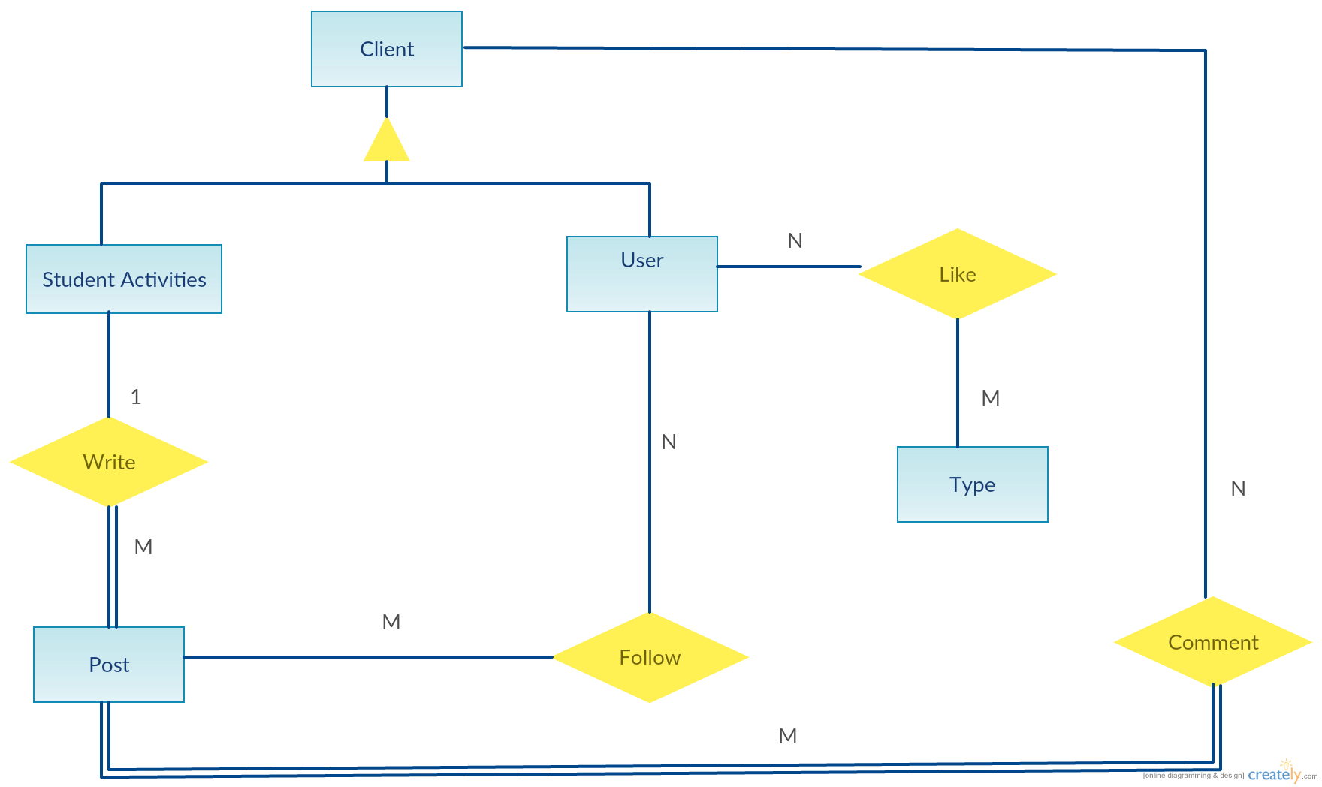

SD-01

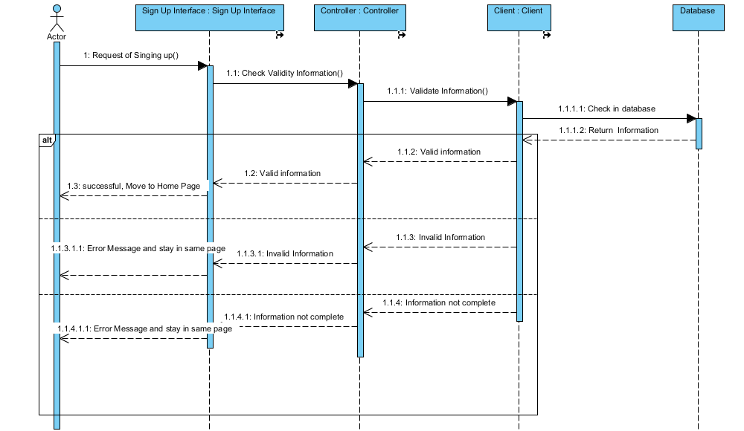

SD-02

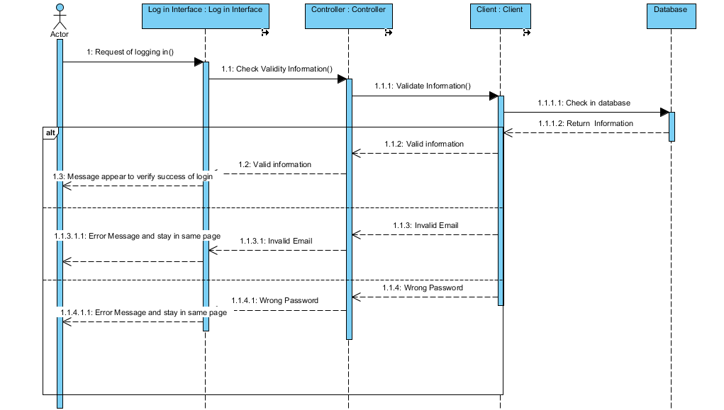

SD-03

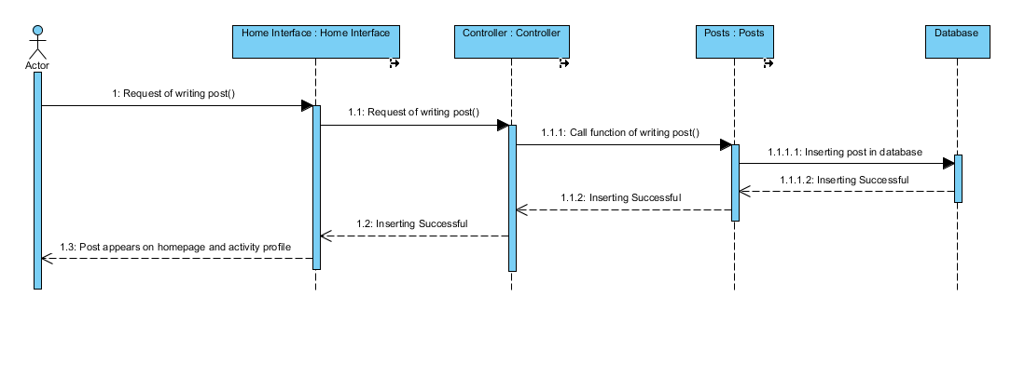

SD-08

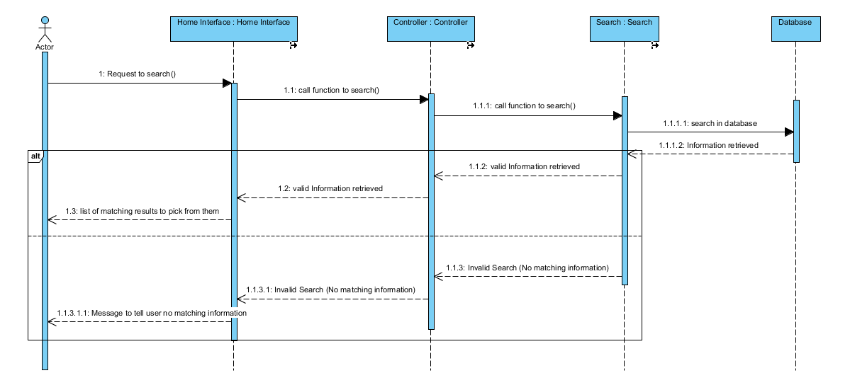

SD-09

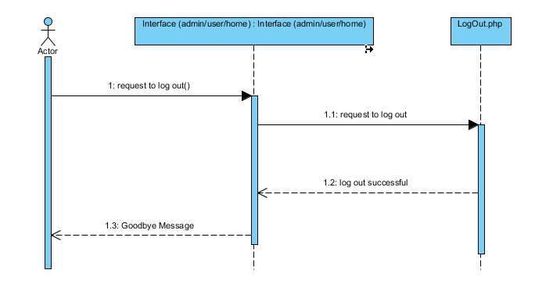

**Traceability to Requirements**

|  |  |  |  |  |  |
| --- | --- | --- | --- | --- | --- |
|  | SD-01 | SD-02 | SD-03 | SD-08 | SD-09 |
| UC-01 | ✓ |  |  |  |  |
| UC-02 |  | ✓ |  |  |  |
| UC-03 |  |  | ✓ |  |  |
| UC-08 |  |  |  | ✓ |  |
| UC-09 |  |  |  |  | ✓ |

Table of definitions

|  |  |
| --- | --- |
| **Term** | **Definitions, Acronyms, and Abbreviations** |
| LEAD | It is the website name and every letter has its meaning which are "Learn", "Explore", "Achieve", and "Develop". |
| Database | Collection of all the information monitored by this system. |
| SD | Sequence Diagram |
| UC | Use Case |
| SDS | Is a written description of a software product, that a software designer writes in order to give a software development team overall guidance to the architecture of the software project. An SDS usually accompanies an architecture diagram with pointers to detailed feature specifications of smaller pieces of the design. |